Lab 1

Observation :

**1-WORKING PROGRAM**

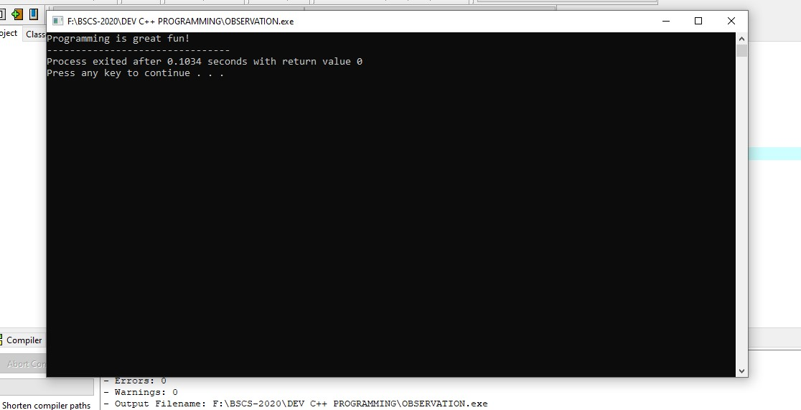

**2- REMOVE SEMI COLON AT THE END OF STATEMENT :**

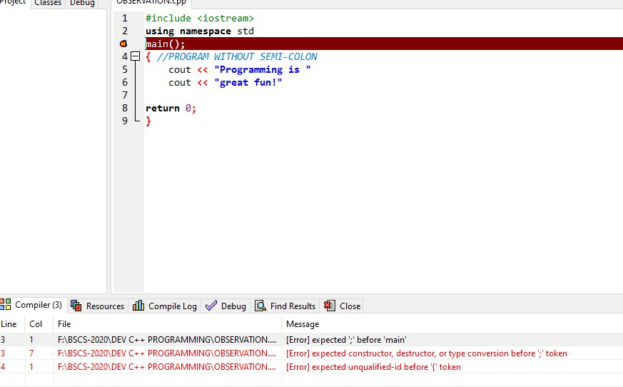

**3- PUTTING SEMI COLON AT THE END OF PRE PROSESSOR DIRECTIVE :**

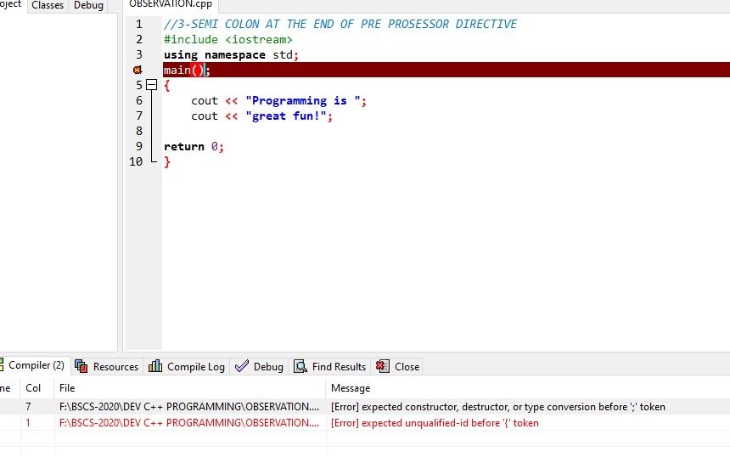

**4-REMOVE LINE #3**

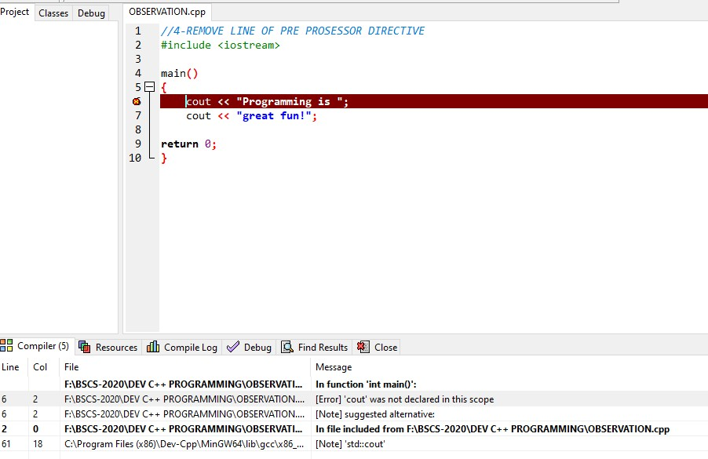

**5-CHANGE THE CASE OF MAIN AND COUT**

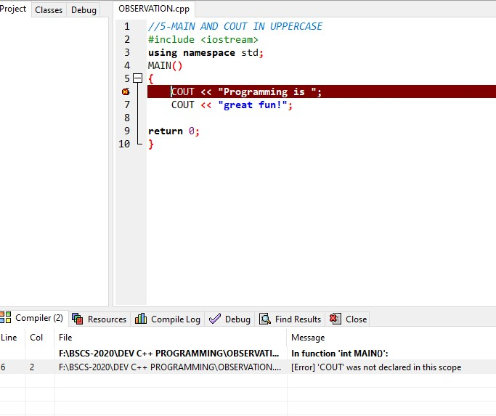

Lab 1

**Task1**

//2- with double quotes cause logical error

#include <iostream>

using namespace std;

main()

**{**//here you see my lab task 1 with double quotes

char first,middle,last;

first ="a";

cout <<"ta";

middle ="b";

cout <<"s";

last ="c";

cout <<"k1";

return 0;

**}**

**Conclusion**

